English Language Learner
Parent Education Program
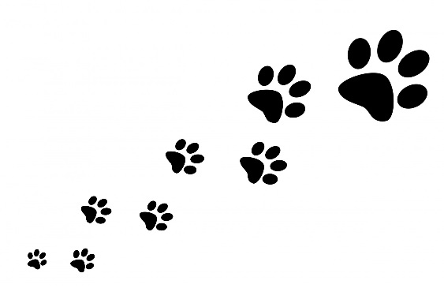
Free Class to Learn English

Class will meet on Thursdays from
6:30 – 8:30 pm
January 22, 2015 – March 26, 2015
In Room 200
at Riverside Brookfield High School
160 Ridgewood Rd., Riverside, Illinois

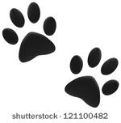

For more information
contact Mari Smith at marieslsmith@gmail.com

